Pokhara University

Level: Bachelor | Semester – Fall | Year : 2011
Programme: BE |  | Full Marks : 100
 |  | Pass Mark : 45
Course: Basic Electrical Engineering |  | Time : 3 hrs

Candidates are required to give their answers in their own words as far as practicable.
The figures in the margin indicate full marks.

Attempt all the questions.

1. | - Find the mesh current I₁, I₂ and I₃ in the circuit given below using the concept of mesh analysis.  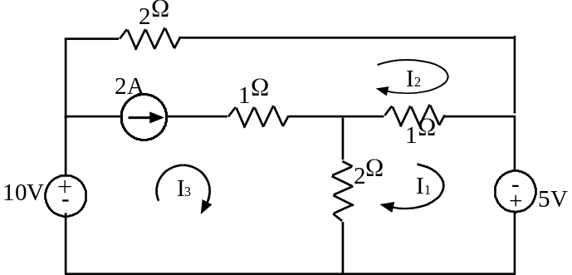  - State Superposition theorem and hence use it to determine the current flowing through R_{L} = 2 ohm in the given circuit.  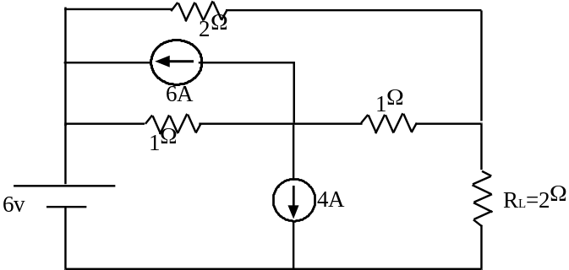 | 7  1+7
2. | - In the series circuit shown, the applied voltage is 100 V of variable frequency. If the frequency is varied till the resonance occurs in the circuit than find the current, resonant frequency, bandwidth, quality factor and the voltage across the inductors and capacitors.  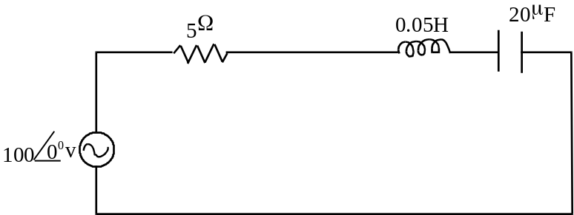  - Utilizing Thevenin’s theorem, find the current in 4 ohm resistance in the circuit given below.  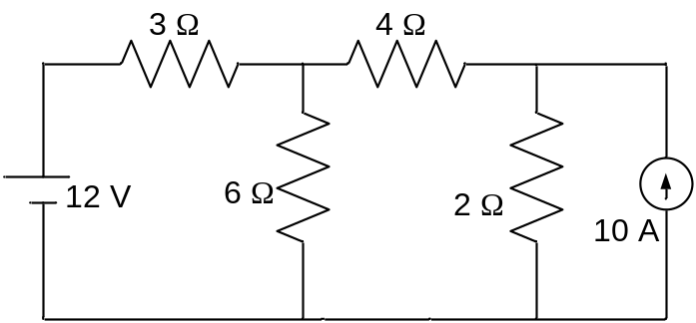  OR  Determine the resistance between the points A and B in the network given below.  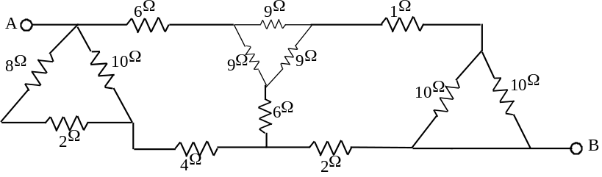 |  |  | 7  8  8
3. | - Determine the average value and form factor of half wave rectified alternating current represented by i = 20sinwt.  OR  Find the root mean square value of the resultant current in a wire which simultaneously directs a current of 2√2A and sinusoidal current of peak value 2√2A.  - Two three phase loads are connected as shown below to a three phase, 220V supply where, Z₁ = (20 + j30) ohm and Z₂ = (30 + j60) ohm. Calculate:  i) Line currents I_{a}, I_{b}, and I_{c}  ii) Current in each delta and wye phase and the line currents drawn by each three phase load and  iii) total power drawn from supply  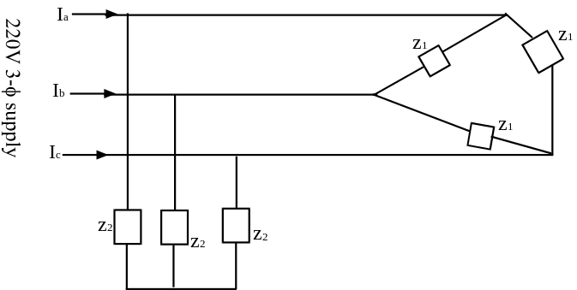 | 3+4  7  8
4. | - What do you mean by power factor? Explain about the significance of power factor.  - Explain at least five advantages of three phase system over single phase system.  - Explain in brief the basic requirements of measuring instruments. | 5  5  5
5. | - Differentiate briefly any four of the following:  - Nodal analysis and Mesh analysis  - Real power and reactive power  - Absolute instrument and secondary instrument  - Ideal transformer and practical transformer  - Motor and generator  - Application of series dc motor and dc shunt motor  - A single phase, 50 KVA, 2200/220 V, 50 Hz, transformer has HV winding resistance of 0.65 ohm and leakage reactance of 0.85 ohm. The corresponding values of LV winding are 0.006 ohm and 0.008 ohm respectively. The shunt branch parameters g_{m} and b_{m} determined at rated voltage and frequency, which viewed from LV side are 0.003S and 0.021S. Draw the equivalent circuit referred to LV side and HV side. | 2×4  7
6. | - What is a DC machine? Deduce the expression for emf generation in DC machines.  OR  Explain the principle of operation of three phase induction motor.  - A 230V dc shunt motor has an armature resistance of 0.1 ohm and a shunt field resistance of 275 ohm. It runs at speed of 1000 rpm when drawing an armature current of 75A. Calculate the additional resistance to be inserted in the field circuit to raise the motor speed to 1200 rpm at an armature current of 125A. Assume linear magnetization characteristics.  OR  Illustrate the speed-torque characteristics of various types of dc motors. Also explain them briefly. | 7  7  8  8
7. | Write short notes on any two:  - Single phase energy meter  - Hysteresis and eddy current loss  - Testing of transformers | 2×5

